Bahria University,

Karachi Campus



LAB EXPERIMENT NO. _13_

LIST OF TASKS

|  |  |
| --- | --- |
| TASK NO | OBJECTIVE |
| Task 1 | Create a program to implement Graphs with Adjacency matrix. |
| Task 2 | Create a program to implement Graphs with Adjacency list. |

Submitted On:

__25/06/2020__

(Date: DD/MM/YYY)

**Task No. 1:**

Create a program to implement Graphs with Adjacency matrix.

**Coding:**

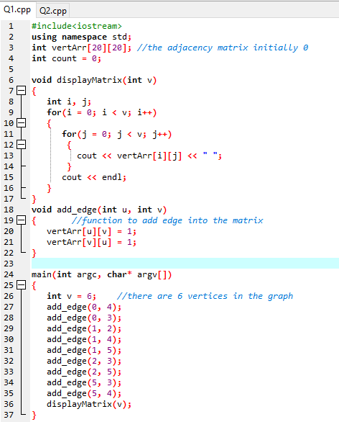

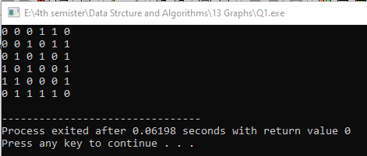**Output:**

**Task No. 2:**

Create a program to implement Graphs with Adjacency list.

**Coding:**

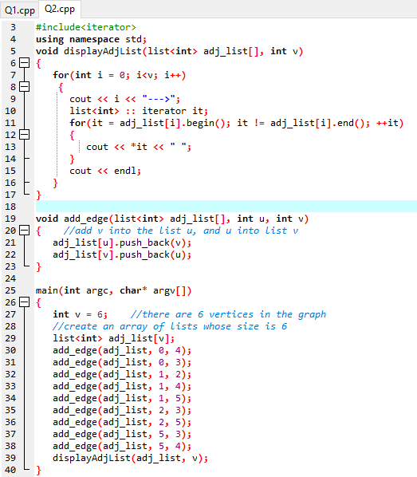

**Output:**

